Introduction to Microservices in .NET
Why Learn Microservices Architecture?
In today’s fast-paced digital world, building scalable, maintainable, and resilient applications is a must. Traditional monolithic applications often struggle to keep up with rapid business changes and growth. This is where Microservices Architecture shines, as it breaks down applications into small, independent, and loosely coupled services that can be developed, deployed, and scaled independently.
Microservices enable faster development cycles, better fault isolation, easier scalability, and seamless integration with cloud-native environments. If you want to build next-generation enterprise applications, learning microservices is no longer optional; it’s essential.
Most modern applications, regardless of their complexity, are organized into three fundamental layers. For a better understanding, please refer to the following image:
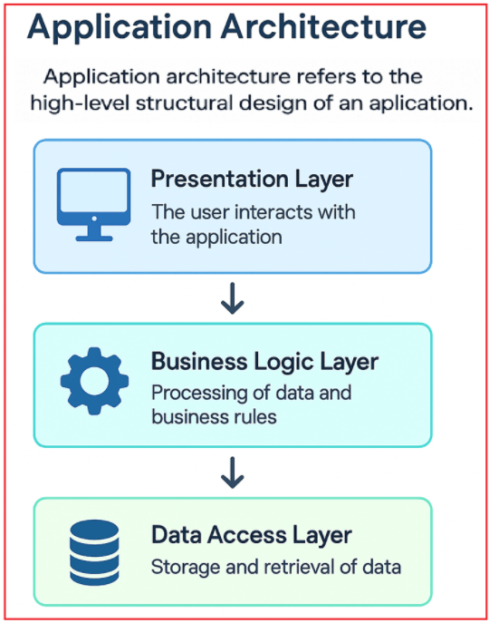
Monolithic Architecture:
In this traditional approach, the entire application, including the user interface (UI), business logic, and data access, is packaged and deployed as a single unit. All layers and components are tightly integrated, which can simplify development initially but may introduce challenges in scaling and maintenance as the application grows.
Monolithic Architecture Explained with an E-commerce Example
Consider an e-commerce application (like a simplified Amazon or Flipkart) implemented using a monolithic architecture.
- The application is built as a single-tier system, where all modules, including user authentication, product catalog, shopping cart, order processing, and payment processing, exist within the same codebase.
- All these modules use a shared database to store and retrieve data, forming a tightly integrated system.
- Changes in one component can directly affect others due to tight integration.
As shown in the diagram below, with monolithic architecture, all components are tightly coupled, sharing a single database.
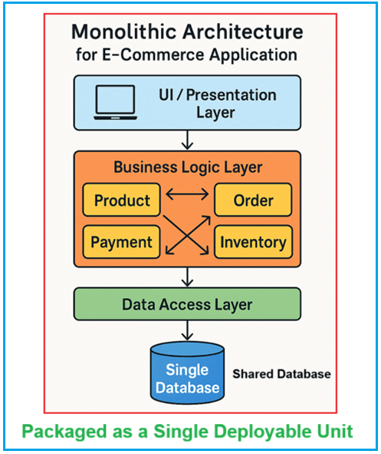
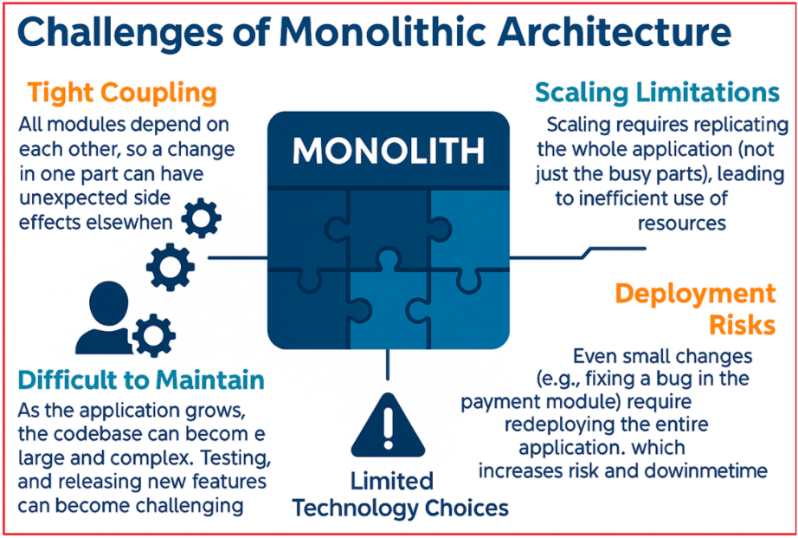
Understanding Each Limitation:
- Tight Coupling: All modules depend on each other, so a change in one part can have unexpected side effects in other parts.
- Scaling Limitations: Scaling requires replicating the entire application (not just the busy parts), leading to inefficient resource utilization.
- Deployment Risks: Even small changes (e.g., fixing a bug in the payment module) require redeploying the entire application, which increases risk and downtime.
- Difficult to Maintain: As the application grows, the codebase can become large and complex. Onboarding new developers, testing, and releasing new features can become challenging.
Microservices Architecture:
In this modern architectural style, the application breaks down into smaller, independently deployable services, each responsible for a specific piece of functionality (such as user authentication, payment processing, or notification delivery). These services communicate with each other over a network, typically via application programming interfaces (APIs). Microservices architectures are more complex to design but offer greater flexibility, scalability, and ease of maintenance.
Microservices Architecture with E-commerce Example:
Imagine an e-commerce platform (like Amazon or Flipkart) built using a microservices architecture. Instead of developing the entire system as a single, unified application, the platform is divided into multiple independent services, each focused on a particular business function. As shown in the diagram below, with a microservices architecture, all components are decoupled, and each component has its own codebase and database.
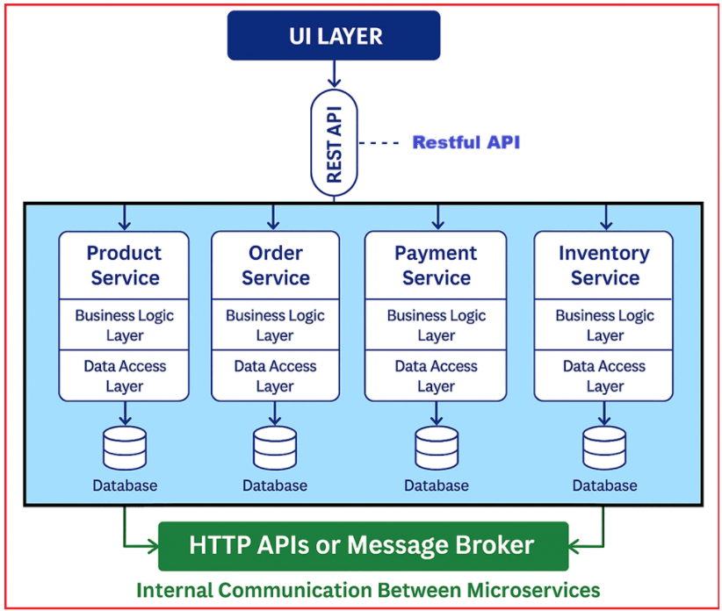

- In microservices architecture, the UI doesn’t directly interact with the business logic in a single codebase. Instead, it communicates with different microservices (such as Product, Order, Payment, and Inventory) via APIs.
- This allows the UI to request specific functionalities (e.g., product details, order processing) directly from the appropriate microservice without going through a single, monolithic backend.
Microservices (Product, Order, Payment, Inventory Services):
Each microservice is an independent, self-contained application with its own codebase, business logic, and database responsible for a distinct business function:
- Product Service: Manages all product-related data, such as adding, updating, and displaying product listings, categories, and product details.
- Order Service: Handles the entire order lifecycle, creating orders, updating order statuses, and managing order histories.
- Payment Service: Processes payments, integrates with payment gateways, manages billing, and handles refunds.
- Inventory Service: Tracks product stock, manages inventory levels, and ensures product availability across the platform.
Each microservice is autonomous. Teams can develop, deploy, scale, and maintain them independently. Each service consists of two key parts:
- Business Logic Layer: The specific rules and operations for that service (e.g., how inventory is updated when an order is placed).
- Data Access Layer: Logic to interact with that service’s own database.
Each microservice has its own isolated database. The Product Service’s database manages product data, Order data by the Order Service’s database, and so on. This isolation prevents unintentional side effects and tight coupling seen in monolithic designs.
Communication Between Services (HTTP API & Message Broker):
To coordinate operations, microservices communicate with each other via:
HTTP APIs:
- Most services expose RESTful APIs, allowing other services or the UI to make requests for specific operations (such as fetching product information, placing an order, or processing a payment).
Message Broker:
- For internal communication between micro services, it uses message brokers (e.g., RabbitMQ, Kafka). This is not for UI layer.
- For example, when an order is placed, the Order Service can send an OrderCreated event through the broker. The Inventory Service receives this event and updates stock levels; the Payment Service can be notified to initiate payment processing.
This decouples services, increases reliability, and supports complex business workflows without direct API calls for every transaction.
Advantages of Microservices Architecture
To understand the advantages associated with the Microservices Architecture, please refer to the following image:
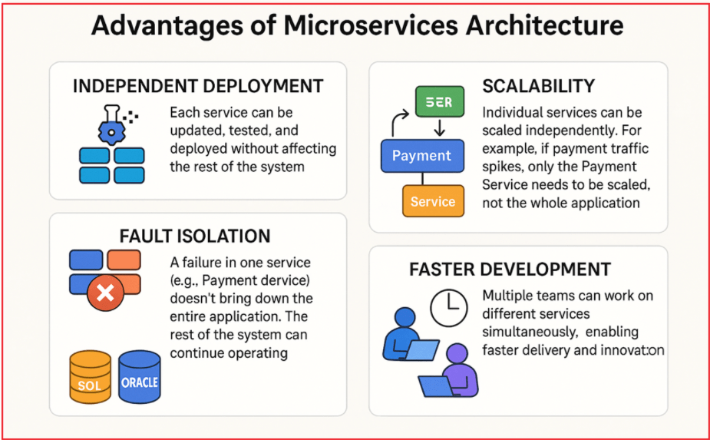

What are Microservices?
Microservices Architecture is a design approach where an application is built as a collection of small, independent, and loosely coupled services.
Each service:
- Handles a specific business functionality
- Has its own database (optional but recommended)
- Can be developed, deployed, and scaled independently
- Communicates with other services using APIs (HTTP/REST, gRPC, Messaging)

Microservices in .NET
In the .NET ecosystem, microservices are typically built using:
- ASP.NET Core – For building RESTful APIs
- Entity Framework Core – For database operations
- Docker – For containerization
- Kubernetes – For container orchestration
- Microsoft Azure – For cloud deployment

Why Use Microservices in .NET?
1️⃣ Independent Deployment
Each service can be deployed separately without affecting others.
2️⃣ Scalability
You can scale only the required service (e.g., Order Service).
3️⃣ Technology Flexibility
Different services can use different databases (SQL Server, MongoDB, etc.).
4️⃣ Better Maintainability
Smaller codebases are easier to manage.

Basic Structure of Microservices in .NET
Example: E-Commerce Application
Instead of one large application, we divide into:
- User Service
- Product Service
- Order Service
- Payment Service
Each service:
- Has its own ASP.NET Core Web API
- Has its own database
- Communicates via HTTP REST APIs or Message Broker

Simple Architecture Diagram (Conceptual)
Client (Web / Mobile App)
⬇
API Gateway
⬇
Microservices (User, Product, Order, Payment)
⬇
Separate Databases

Communication Between Services
- Synchronous Communication
  - REST APIs using HTTP
  - gRPC
- Asynchronous Communication
  - Message Queue (RabbitMQ, Azure Service Bus)

Microservices vs Monolithic Architecture
Monolithic | Microservices
Single large project | Multiple small services
Single database | Separate databases
Hard to scale specific modules | Easy to scale individual services
One deployment | Independent deployment

When to Use Microservices?
Use Microservices when:
- Application is large and complex
- Multiple teams are working
- High scalability is required
- Continuous deployment is needed
Avoid Microservices when:
- Small project
- Small team
- Simple CRUD application

Step-by-Step Microservices Example in .NET Core
Let’s build a simple microservices example using:
- Product Service
- Order Service
Each service will be a separate ASP.NET Core Web API project.
We will use:
- ASP.NET Core
- Entity Framework Core
- SQL Server

✅ Step 1: Create Solution
Open Visual Studio or CLI.
Create Solution
dotnet new sln -n ECommerceMicroservices

✅ Step 2: Create Product Service
dotnet new webapi -n ProductService
dotnet sln add ProductService

Step 2.1: Install EF Core Packages
Inside ProductService:
dotnet add package Microsoft.EntityFrameworkCore.SqlServer
dotnet add package Microsoft.EntityFrameworkCore.Tools

Step 2.2: Create Product Model
📁 Models/Product.cs
using System.ComponentModel.DataAnnotations;

namespace ProductService.Models
{
public class Product
{
public int Id { get; set; }

[Required]
public string Name { get; set; }

public decimal Price { get; set; }
}
}

Step 2.3: Create DbContext
📁 Data/ProductDbContext.cs
using Microsoft.EntityFrameworkCore;
using ProductService.Models;

namespace ProductService.Data
{
public class ProductDbContext : DbContext
{
public ProductDbContext(DbContextOptions<ProductDbContext> options)
: base(options) { }

public DbSet<Product> Products { get; set; }
}
}

Step 2.4: Configure Connection String
📁 appsettings.json
"ConnectionStrings": {
"DefaultConnection": "Server=.;Database=ProductDB;Trusted_Connection=True;TrustServerCertificate=True;"
}

Step 2.5: Register DbContext
In Program.cs:
builder.Services.AddDbContext<ProductDbContext>(options =>
options.UseSqlServer(builder.Configuration.GetConnectionString("DefaultConnection")));

Step 2.6: Create Product Controller
📁 Controllers/ProductsController.cs
using Microsoft.AspNetCore.Mvc;
using ProductService.Data;
using ProductService.Models;

namespace ProductService.Controllers
{
[Route("api/[controller]")]
[ApiController]
public class ProductsController : ControllerBase
{
private readonly ProductDbContext _context;

public ProductsController(ProductDbContext context)
{
_context = context;
}

[HttpGet]
public IActionResult Get()
{
return Ok(_context.Products.ToList());
}

[HttpPost]
public IActionResult Create(Product product)
{
_context.Products.Add(product);
_context.SaveChanges();
return Ok(product);
}
}
}

Step 2.7: Run Migration
dotnet ef migrations add InitialCreate
dotnet ef database update

Now Product Service is ready.

✅ Step 3: Create Order Service
dotnet new webapi -n OrderService
dotnet sln add OrderService

Step 3.1: Create Order Model
📁 Models/Order.cs
namespace OrderService.Models
{
public class Order
{
public int Id { get; set; }
public int ProductId { get; set; }
public int Quantity { get; set; }
}
}

Step 3.2: Create Orders Controller
📁 Controllers/OrdersController.cs
using Microsoft.AspNetCore.Mvc;
using OrderService.Models;
using System.Net.Http.Json;

namespace OrderService.Controllers
{
[Route("api/[controller]")]
[ApiController]
public class OrdersController : ControllerBase
{
private readonly HttpClient _httpClient;

public OrdersController(IHttpClientFactory factory)
{
_httpClient = factory.CreateClient();
}

[HttpPost]
public async Task<IActionResult> Create(Order order)
{
var product = await _httpClient
.GetFromJsonAsync<object>($"https://localhost:5001/api/products/{order.ProductId}");

if (product == null)
return BadRequest("Invalid Product");

return Ok(order);
}
}
}

Step 3.3: Register HttpClient
In Program.cs:
builder.Services.AddHttpClient();

✅ Step 4: Run Both Services
- Run ProductService → https://localhost:5001
- Run OrderService → https://localhost:5002
Test flow:
- Add Product via ProductService
- Create Order via OrderService
- OrderService calls ProductService API

Client → OrderService → ProductService → Database
Each service:
- Separate project
- Separate database
- Independent deployment

